**Installation and User Guide**

1 Getting Started

1.1 Quick Start

For a quick-start, a demo system has been deployed on the Tencent Cloud Server, and the only system requirement is a modern web browser. You can also access it from your mobile phone.

Steps:

Launch your web browser and visit <http://43.134.45.203/>.

Note:

The cloud server is rented for one month, and it will expire on 2023-11-24. If the server becomes inaccessible, you can try installing the system on your local computer.

1.2 Full Installation

System Requirements

The Intelligent Album Generator can only been run on macOS or Linux systems. This is because we use a python package called pyheif to read HEIC image formats, which compatible only with macOS and Linux.

Dependencies

* Anaconda
* A modern web browser

Pre-requisites

* Clone or download project source code from GitHub repository.

Starting the System

1. Navigate to the backend code in your local copy of the GitHub repository at `\system_code\backend`. You can check the current path using command `pwd`.



1. Open the terminal and install the

`conda create -n album python=3.11`

`conda activate album`



After running these commands, your conda environment should be set to “album”.

1. Install the required Python project dependencies:

`pip install -r requirements.txt`

1. Run app.py by entering the following command in the console to start the backend server:

`python -m flask run --host=0.0.0.0`

If console displays the following message, the backend server has starts successfully.

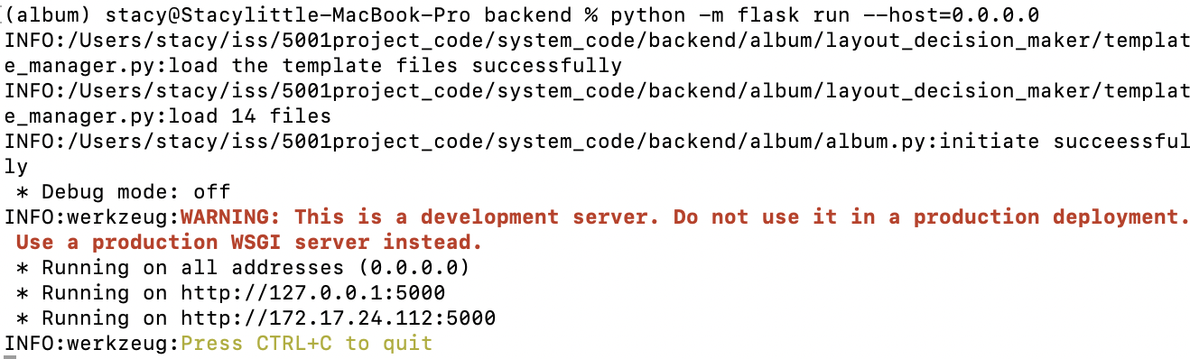

1. Navigate to the frontend path to open `index.html` to join the system immediately.

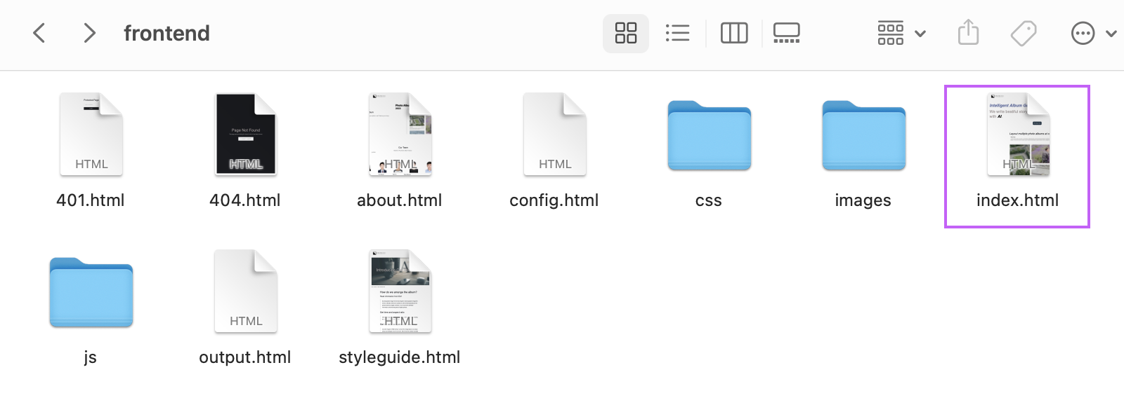

2 User Guide

2.1 Generate Your First Album

When you double-click `index.html` file in the frontend document, you can explore our website. The website consists of three main pages: Home, About and Tech. You can create your first album on the home page. If you have any questions about using the system, you can contact us on the About page. The Tech page provides technical details about the system.

To create your first album, follow these steps:

1. Click on the “Write Story now” button on the home page. You will be redirected to the configuration page where you can upload your images and adjust your settings.

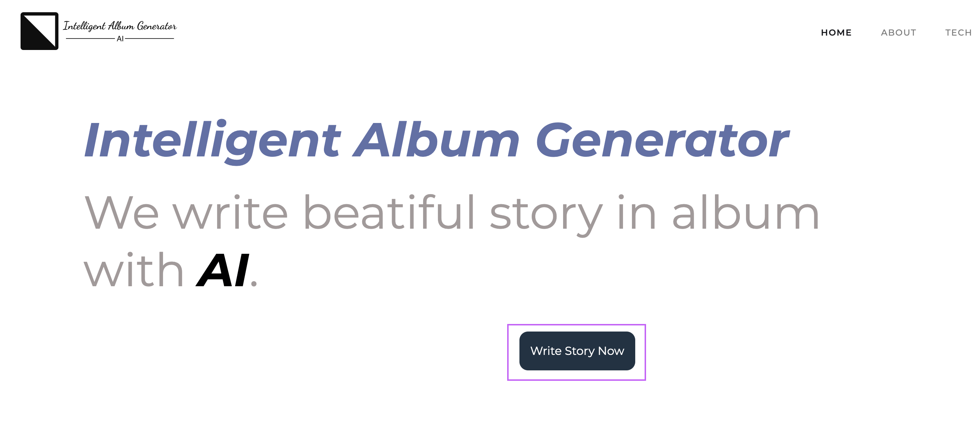

1. After you’ve filled in all the options, click the “submit” button to generate your album. If you choose “Yes” in the background recognition option, it may take a bit longer as the system will run a background recognition model to get the background features, which requires some time.

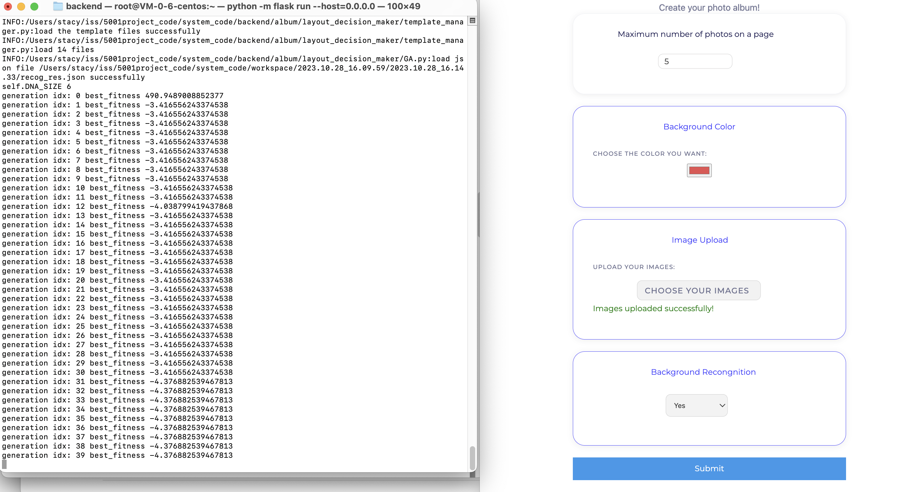

1. You can also monitor the process in the console. After 50 iterations of genetic algorithm, the system will determine the optimal layout plan and generate the album as a PDF file. You can find local path to the PDF in the console, and the website will automatically jump to PDF browsing page.

